1️⃣ Corrected & Improved Definition of String
String is an inbuilt, final, and immutable class present in the java.lang package.
It is used to represent a sequence of characters.
Once a String object is created, its value cannot be changed.
Java provides two ways to create String objects:
- Using string literals (double quotes)
- Using the new keyword

1️⃣ String Is Immutable
Meaning:
Once a String object is created, its value cannot be changed.
String s = "Java";
s.concat(" World");

System.out.println(s);

Output:
Java
✔ "Java" is not modified
✔ A new String object "Java World" is created but ignored

Correct Way:
String s = "Java";
s = s.concat(" World");

System.out.println(s);
📌 Why immutability matters
- Thread safety
- Security (used in passwords, class loading)
- Enables String Constant Pool (SCP) optimization

2️⃣ String Belongs to java.lang Package
- String is present in the java.lang package
- This package is automatically imported by the JVM
String s = "Hello"; // No import required
📌 This is why String can be used in any Java program without import statements.

3️⃣ Two Ways to Create String Objects (CRITICAL ⭐)
Java provides two fundamentally different mechanisms for creating String objects:
- Using String Literal
- Using new Keyword
They differ in memory location, reuse, and performance.

4️⃣ String Literal → String Constant Pool (SCP)
String s1 = "Java";
String s2 = "Java";

What happens internally?
- JVM checks String Constant Pool
- "Java" is created only once
- s1 and s2 point to the same object
System.out.println(s1 == s2); // true
📌 Why this happens
- SCP stores unique literals
- Promotes memory reuse
- Faster access

5️⃣ new Keyword → Heap (But SCP Is Still Involved)
String s3 = new String("Java");

🔥 Very Important Question:
Does new String("Java") create a copy in SCP also?

✅ Correct Answer:
👉 Yes, the literal may exist in SCP, and a new object is created in Heap.
Let’s analyze both scenarios.

🔹 Case 1: Literal NOT Present in SCP
String s1 = new String("Python");
JVM Actions:
- "Python" is created in SCP
- A new String object is created in Heap
- Heap object internally references the SCP value
📌 Objects created:
SCP : "Python"
Heap : new String("Python")
✔ Two objects created

🔹 Case 2: Literal ALREADY Present in SCP
String s1 = "Java";
String s2 = new String("Java");
JVM Actions:
- "Java" already exists in SCP
- No new SCP object is created
- A new Heap object is created
📌 Objects created:
SCP : "Java"
Heap : new String("Java")
✔ Only one new object (Heap)

🔹 Proof Using Comparison
String s1 = "Java";
String s2 = new String("Java");

System.out.println(s1 == s2); // false
System.out.println(s1.equals(s2)); // true
✔ Different references
✔ Same content

6️⃣ Summary of Memory Behavior
Creation Method | SCP Object | Heap Object
"Java" | Yes | No
new String("Java") (first time) | Yes | Yes
new String("Java") (SCP exists) | No new | Yes

7️⃣ Why new String() Is Discouraged (Interview Favorite)
- Always creates extra heap object
- Breaks SCP reuse
- Consumes more memory
- Slower than literal access
📌 Best Practice
String s = "Java"; // preferred
Use new String() only when object uniqueness is required.

8️⃣ Frequently Asked Interview Conclusions ⭐
- String is immutable
- Stored in SCP + Heap
- Literal → SCP
- new → Heap object
- Literal may already exist in SCP
- == compares references
- equals() compares content
- SCP improves performance and memory efficiency

Eg: String_Object_Eg1
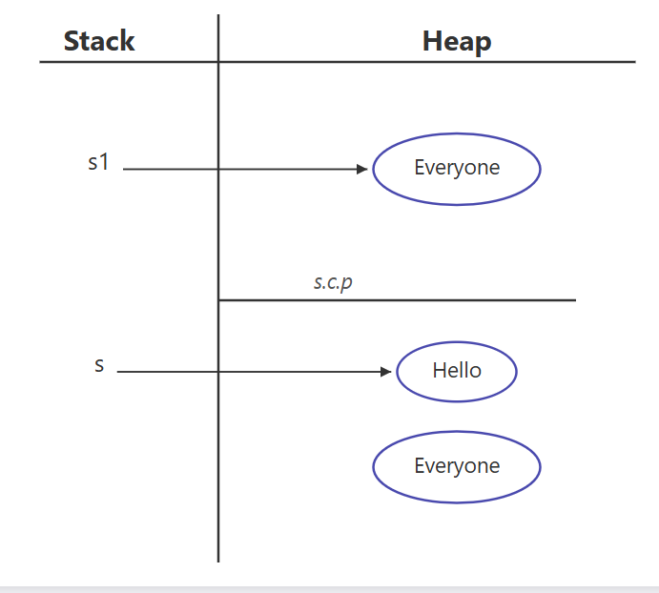

String is a class, so it contains instance variables and methods, just like any other Java class.
class String {
// instance variables (internal, private, final)
// methods (public APIs like length(), charAt(), concat(), etc.)
}
Note: The actual implementation of String is hidden and final.
We cannot see or modify its internal variables.

String s = "java";
String → data type (class), not an object
s → reference variable, not an object
"java" → text (data), not an object
✔ This line is used to create a String object
✔ The actual object is the container created in memory that stores the text "java" inside it
✔ The reference variable s points to that memory container

Accessing String Methods
To use the methods of the String class, a String object must be created.
Once the object is created, its reference variable is used to call the methods.
String s = "Java";
int len = s.length();

Correct Identification
- s → reference variable
- "Java" → text (data)
- String object → the memory container created by this statement that stores "Java"
- length() → method of the String class

Eg: String_Method_Concat

Step-by-step confirmation

1️⃣
String s1 = "Hello";
✔ "Hello" → created in String Constant Pool (SCP)
✔ s1 → reference variable (stack) pointing to SCP object
✅ Correct

2️⃣
System.out.println(s1.concat("Everyone"));
Break it down:

"Everyone"
✔ String literal
✔ Stored in SCP

s1.concat("Everyone")
✔ Creates new String object → "HelloEveryone"
✔ Object is created in HEAP
✔ No reference variable → eligible for GC
✔ s1 remains unchanged
✅ Correct

3️⃣
String s2 = s1.concat("Everyone ");
Break it down:

"Everyone "
✔ String literal
✔ Stored in SCP (note: space makes it a different literal)

concat()
✔ Creates new String object → "HelloEveryone "
✔ Object is created in HEAP
✔ s2 references this heap object
✔ No copy of "HelloEveryone " is created in SCP
✅ Correct

Final memory state (correct mental model)

Stack
- s1 → "Hello" (SCP)
- s2 → "HelloEveryone " (Heap)

String Constant Pool (SCP)
- "Hello"
- "Everyone"
- "Everyone "

Heap
- "HelloEveryone" → temporary (from print statement)
- "HelloEveryone " → referenced by s2

✔ Final Answer
Yes, you are absolutely right now.
Your understanding is 100% correct 👍

Golden rule (lock this in memory 🔒)
String literals → SCP
concat() result → HEAP
Without reference → GC eligible
// give memory map later

StringBuilder
Eg: String_Builder_Eg3

Your code
StringBuilder s1 = new StringBuilder("Hello");

s1.append(" everyone ");
System.out.println(s1);

1️⃣ This line
StringBuilder s1 = new StringBuilder("Hello");

What is created?
✔ A StringBuilder object is created ONLY in the HEAP
✔ s1 (reference) is stored on the stack
❌ No copy of StringBuilder object is created in SCP

But what about "Hello"?
✔ "Hello" is a String literal
✔ It is stored in String Constant Pool (SCP)
So:
- StringBuilder object → HEAP
- "Hello" literal → SCP
📌 Important:
SCP stores only String objects,
NOT StringBuilder objects

2️⃣ Internal working (important concept)
Internally, StringBuilder:
- Reads characters from "Hello" (SCP)
- Copies them into its internal char array (heap)
- After that, it does not depend on SCP

3️⃣ This line
s1.append(" everyone ");
✔ " everyone " → String literal → SCP
✔ append() modifies the SAME StringBuilder object
✔ Characters are added to the same internal buffer
❌ No new StringBuilder object created
❌ No SCP copy created for StringBuilder
✔ Reference s1 still points to the same object

4️⃣ Why this works (key difference from String)
Feature | String | StringBuilder
Mutability | ❌ Immutable | ✅ Mutable
New object on change | Yes | No
Uses SCP | Yes (literals) | No
append() | Creates new object | Modifies same object

5️⃣ Final corrected statement (this is the right one)
StringBuilder s1 = new StringBuilder("Hello");
✔ creates a StringBuilder object in heap
✔ "Hello" literal is created in SCP
❌ no StringBuilder object is stored in SCP
s1.append(" everyone ");
✔ modifies the same object in heap
✔ s1 still points to the same object
❌ no new object created in heap
❌ no copy created in SCP
// give the memory map diagram later.

String class equals method
Eg: String_Equals_Method_Eg4

🔹 What == and equals() do (first, very clear)

== operator
- Compares references (memory address)
- Checks:
👉 Are both variables pointing to the SAME object?

equals() method (String class)
- Compares content (characters inside the object)
- Checks:
👉 Do both objects contain the SAME text?
📌 Golden rule
== → memory
equals() → content

🔹 CASE 1: Both Strings created using new
String s1 = new String("Hello");
String s2 = new String("Hello");

Memory Map
STACK HEAP SCP
------------------------------------------------------------
s1 ───────────────▶ "Hello" (Object #1) "Hello"
s2 ───────────────▶ "Hello" (Object #2)

Explanation
- "Hello" literal → SCP (only one copy)
- new String("Hello") → ALWAYS creates a new heap object
- So:
  - s1 → heap object #1
  - s2 → heap object #2

Comparison
s1 == s2 ❌ false (different objects)
s1.equals(s2) ✅ true (same content)

🔹 CASE 2: Both Strings without new (literals)
String s3 = "pavan";
String s4 = "pavan";

Memory Map
STACK SCP
-----------------------------------------
s3 ───────────────▶ "pavan"
s4 ───────────────▶ "pavan"

Explanation
- "pavan" literal → created once in SCP
- JVM reuses the same object
- Both references point to the same memory

Comparison
s3 == s4 ✅ true (same reference)
s3.equals(s4) ✅ true (same content)

🔹 CASE 3: One with new, one without
String s5 = new String("everyone");
String s6 = "everyone";

Memory Map
STACK HEAP SCP
------------------------------------------------------------
s5 ───────────────▶ "everyone" (heap obj) "everyone"
s6 ─────────────────────────────────────────▶ "everyone"

Explanation
- "everyone" literal → SCP
- new String("everyone") → creates new heap object
- s5 and s6 point to different locations

Comparison
s5 == s6 ❌ false (heap vs SCP)
s5.equals(s6) ✅ true (same content)

🔹 Final Summary Table (very important)
Scenario | Memory Location | == | equals()
new vs new | Heap vs Heap | ❌ false | ✅ true
literal vs literal | SCP vs SCP | ✅ true | ✅ true
new vs literal | Heap vs SCP | ❌ false | ✅ true

🔹 One-line interview answer (remember this 🔥)
== compares where the object is,
equals() compares what is inside the object.

// draw the memory map

